University of Central Punjab

**Faculty of Information Technology**

# Data Structures and Algorithms

# Fall 2025

|  |  |  |
| --- | --- | --- |
| **Assignment 03** | |  |
| **Topic** | * Recursion and BST |
| **Objective** | * The basic purpose of this Assignment is to learn and implement BST |
|  | | |

# Instructions

* Write the following functions of BST within BST class

## Function 1:

Write down the following **codes (recursive)** for tree traversals:

1. In-order
2. Post-Order
3. Pre-Order

Note: We have already done the recursive codes of traversal in our lectures.

## Function 2:

Write a function to count the total number of **leaf nodes** in a Binary Search Tree.

## Function 3:

Write function to count the **total number of nodes** in a Binary Search Tree.

## Function 4:

Write a recursive function to check if a given binary tree is a BST.

Example:

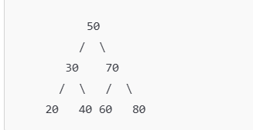

## Function 5:

Check if a Tree is a Perfect BST

A perfect BST is one where all internal nodes have two children and all leaf nodes are at the same level. Write a function to check whether a given tree is a perfect BST.

Example:

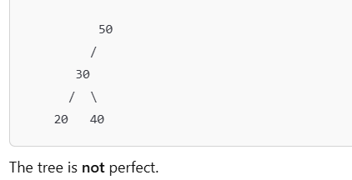

## Function 6:

Write a function to find the common nodes between two BSTs.

Example:

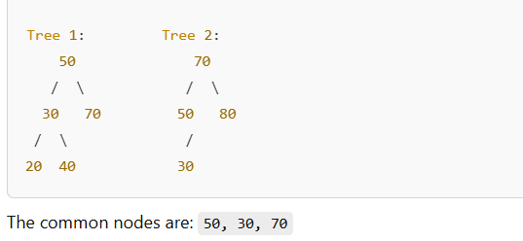

## Function 7:

Write a function to find the **second largest element** in a BST. You can find this element using in-order traversal or by using a method that directly navigates the tree based on the BST properties.

**Example:**

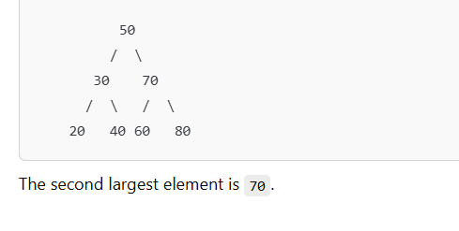

## Function 7:

Write a function to find the lowest common ancestor (LCA) of two given nodes in a BST. The LCA is the deepest node that is an ancestor of both nodes.

Example

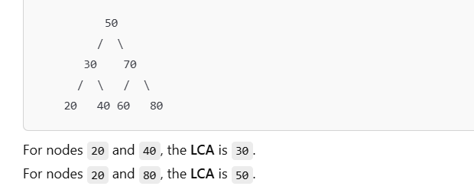

## Function 8:

Write a function to convert a sorted array into a balanced BST. The array is already sorted, and the goal is to construct the BST in such a way that the tree remains balanced.

Example

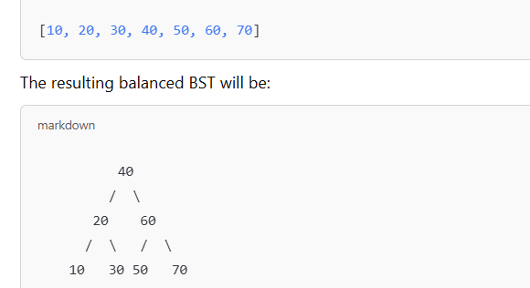

## Function 9:

Write a function to check if two BSTs are identical. Two BSTs are considered identical if they have the same structure and the same values in corresponding nodes.

Example

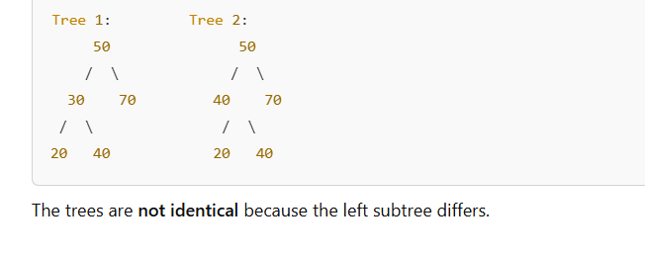

## Function 10:

Write a function to find the maximum and minimum values in a BST. Use the properties of BSTs to efficiently find the values.

Example

